Python Django Internship Report

**Personal Details:**

Name : Riya Shrivastav

College Name : Swarrnim Institute of Technology

Degree : BTech

Semester : 8

Github URL : https://github.com/sriya257/Python-Django.git

**Company Details:**

Company Name : Akash Technolabs

External Guide : Akash Padhiyar

Training Duration : 26-05-2021 to 21-06-21

Index

|  |  |  |  |
| --- | --- | --- | --- |
| Index | Task Details | Page Name | |
| 1 | Calculate average of 5 numbers. | 4 | |
| 2 | Check whether number is even or odd. | 5 | |
| 3 | Take a year and check whether it is leap year or not. | 6 | |
| 4 | Take a number and check whether it is zero, positive or negative. | 7 | |
| 5 | Take 2 numbers and display greatest number. (Also check equal number condition) | 8 | |
| 6 | Take a number and find factorial of that number. | 9 | |
| 7 | Write a program to swap 2 numbers using third variable. | 10 | |
| 8 | Take 2 numbers and find smallest number. | 11 | |
| 9 | Take a number check if a number is less than 100 or not. If it is less than 100 then check if it is odd or even. | 12 | |
| 10 | Take a number to print the square of a number if it is less than 10. | 13 | |
| 11 | Take a number and check whether it is zero, positive or negative using nested IF…ELSE statement. | 14 | |
| 12 | Take 3 numbers and find greatest number using Nested IF…ELSE statement. | 15 | |
| 13 | Take 3 numbers and find smallest number using logical operator. | | 16 |
| 14 | Write a program to swap 2 numbers without taking third variable. | | 17 |
| 15 | Take Starting number and ending number from the user and print following series.  Output :-  Enter starting number : 30  Enter ending number : 0  30  27  24  21  18  15  12  9  6  3  0 | | 18 |
| 16 | Make a Website using registration form and signup and display it on second page. | | 19-27 |

Note :- Take all values from the User.

Practical 1:- Calculate average of 5 Numbers.

Code:

n1 = int(input(**"Enter a Number: "**))  
n2 = int(input(**"Enter a Number: "**))  
n3 = int(input(**"Enter a Number: "**))  
n4 = int(input(**"Enter a Number: "**))  
n5 = int(input(**"Enter a Number: "**))  
  
avg = (n1 + n2 + n3 + n4 + n5) / 5  
print(avg)

O/P:

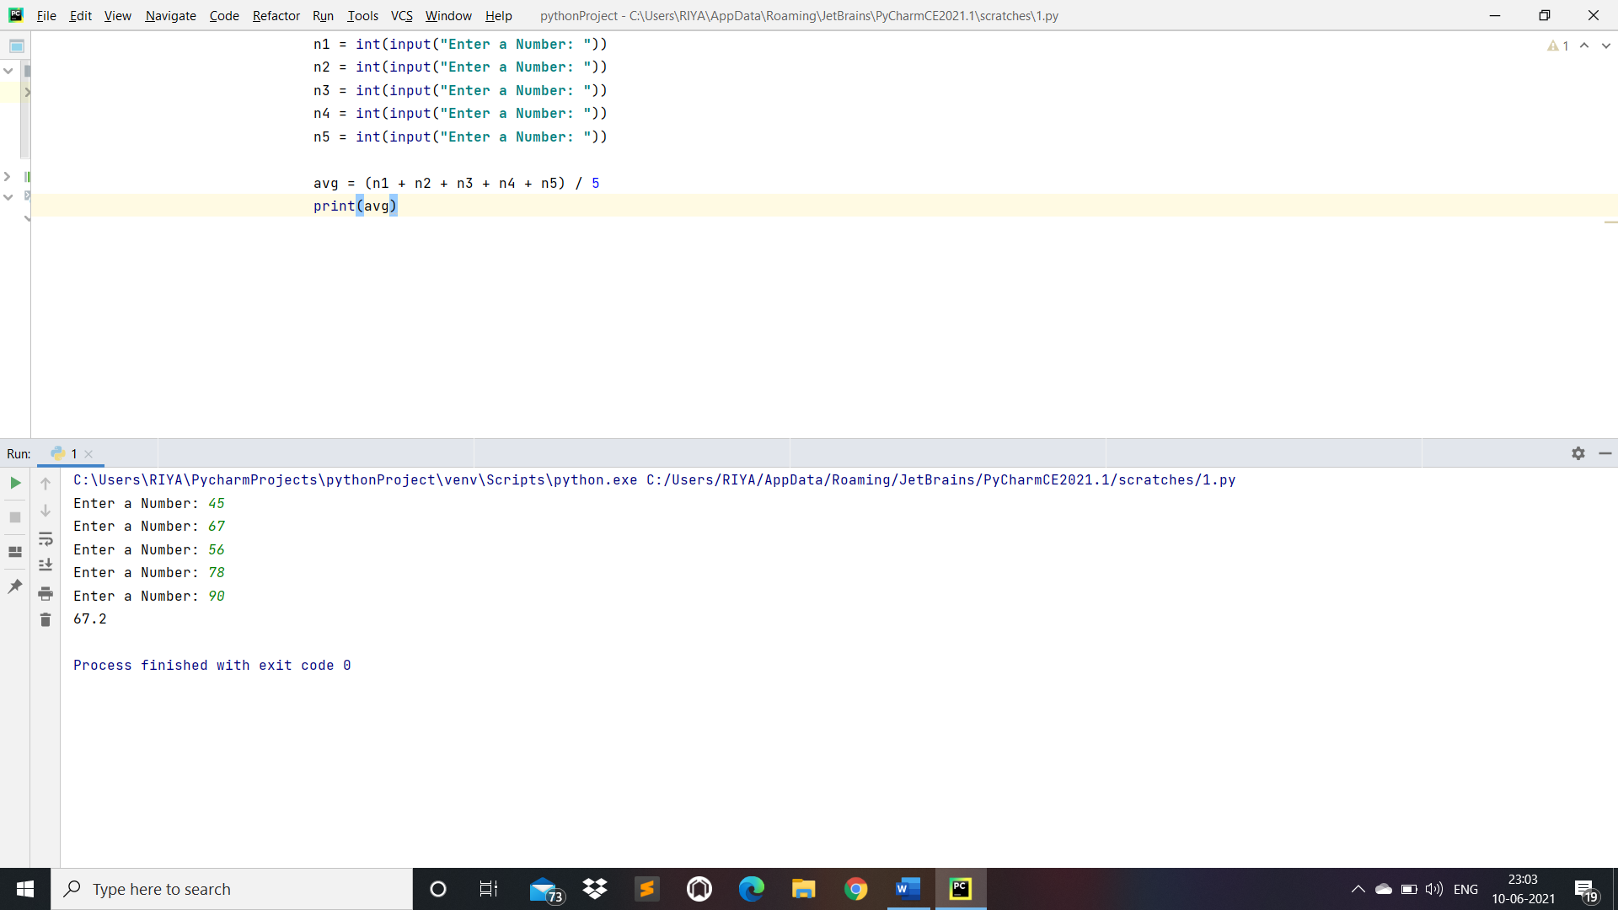

Practical 2:- Check whether number is even or odd.

Code:

n = int(input(**"Enter a Number:"**))  
  
**if** (n % 2) == 0:  
 print(**"n is even"**)  
  
**else**:  
 print(**"n is odd"**)

O/P:

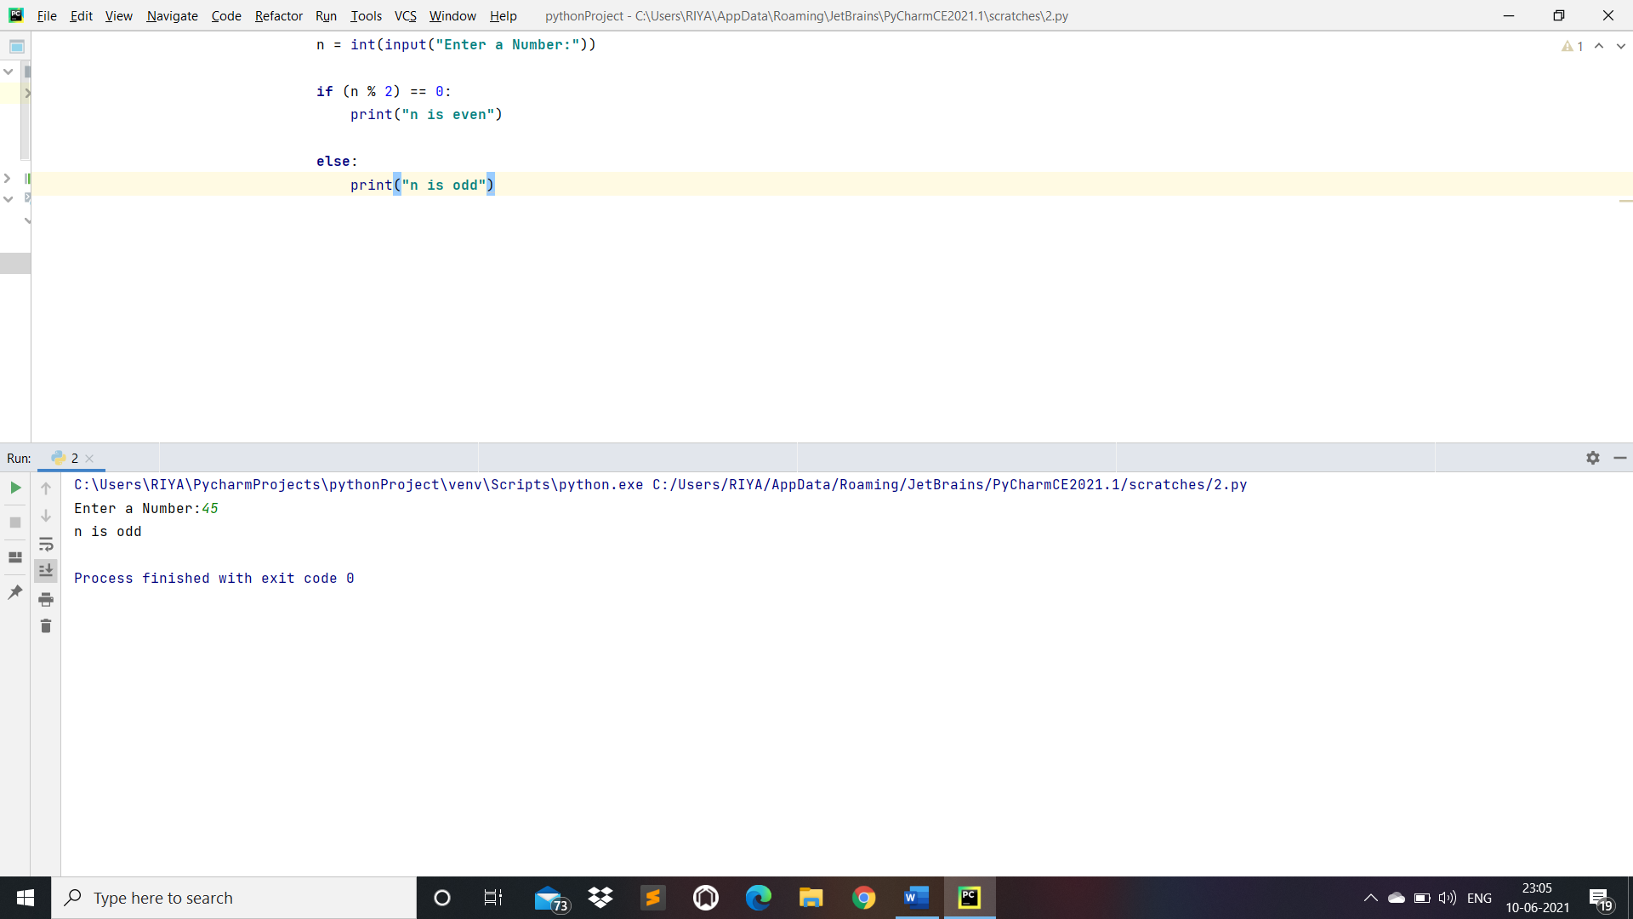

Practical 3:- Take a year and check whether it is leap year or not.

Code:

year = int(input(**"Enter a Year:"**))  
  
**if** year % 4 == 0:  
 **if** year % 100 == 0:  
 **if** year % 400 == 0:  
 print(**" It is a leap year"**)  
 **else**:  
 print(**"It is not a leap year"**)  
 **else**:  
 print(**"It is not a leap year"**)  
**else**:  
 print(**"It is not a leap year"**)

O/P:

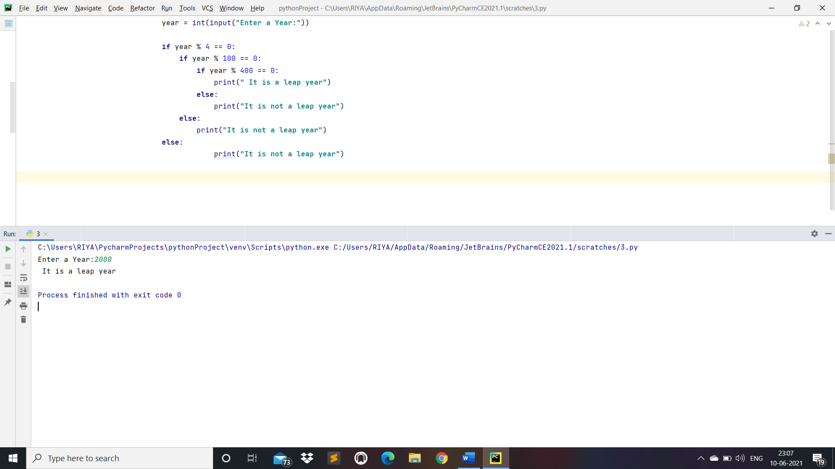

Practical 4:- Take a number and check whether it is zero, positive or negative.

Code:

x = int(input(**"Enter a Number:"**))  
  
**if** x > 0:  
 print(**"x is positive"**)  
  
**elif** x == 0:  
 print(**"x is zero"**)  
  
**else**:  
 print(**"x is negative"**)

O/P:

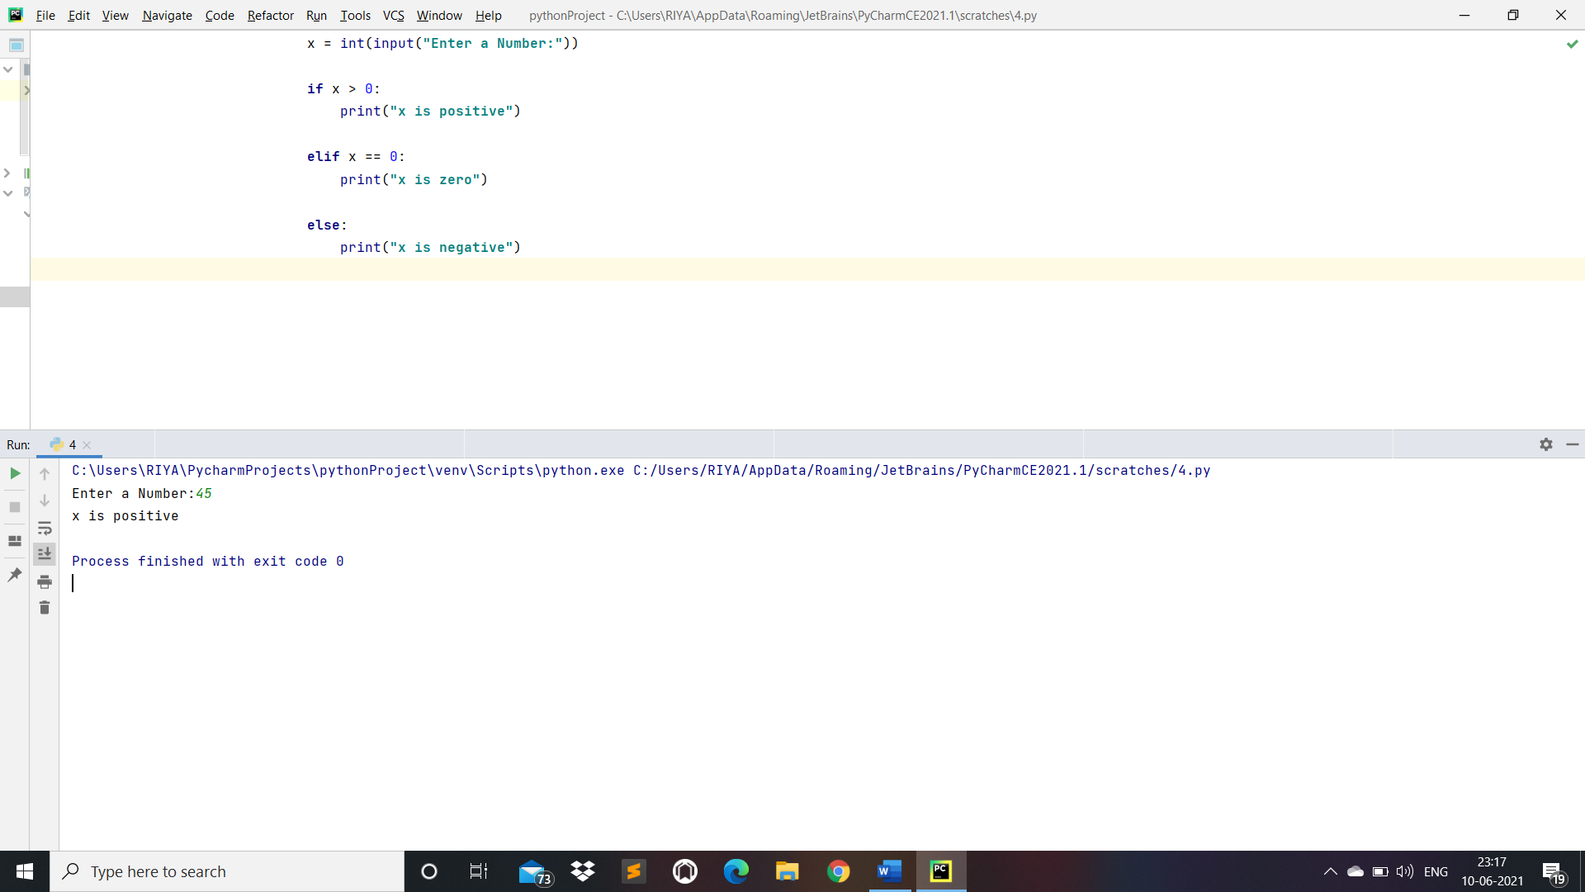

Practical 5:- Take 2 numbers and display greatest number.(Also check equal number condition)

Code:

x = int(input(**"Enter a Number: "**))  
y = int(input(**"Enter a Number: "**))  
  
**if** x == y:  
 print(**"Both the values are equal"**)  
  
**elif** x > y:

print(**"x is larger number"**)  
  
**else**:  
 print(**"y is larger number"**)

O/P:

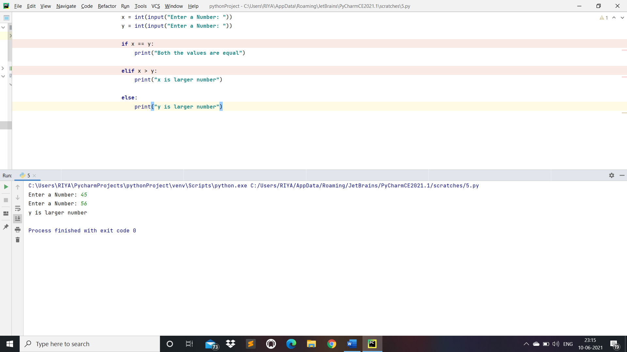

Practical 6:- Take a number and find factorial of that number.

Code:

num = int(input(**"Enter a Number:"**))  
factorial = 1  
**if** num < 0:  
 print(**"Factorial doesn't exists for negative numbers"**)  
**elif** num == 0:  
 print(**"The Factorial of 0 is 1"**)  
**else**:  
 **for** i **in** range(1, num + 1):  
 factorial = factorial*i  
 print(**"The Factorial of"**,num,**"is"**,factorial)

O/P:

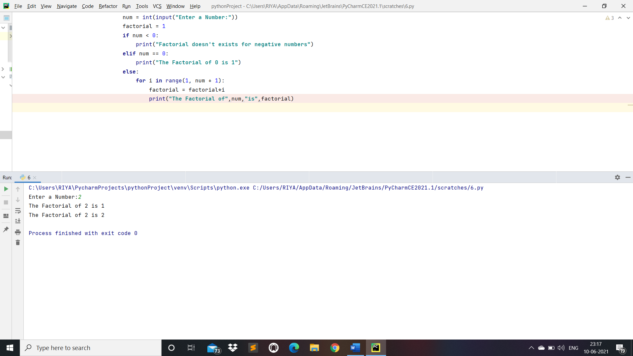

Practical 7:- Write a program to swap 2 numbers using third variable.

Code:

*# Swap two numbers by using third Variable*a = int(input(**"Enter a Number:"**))

b = int(input(**"Enter a Number:"**))  
  
temp = a  
a = b  
b = temp  
print(**"The value of a after swapping: "**,a)  
print(**"The value of b after swapping: "**,b)

O/P:

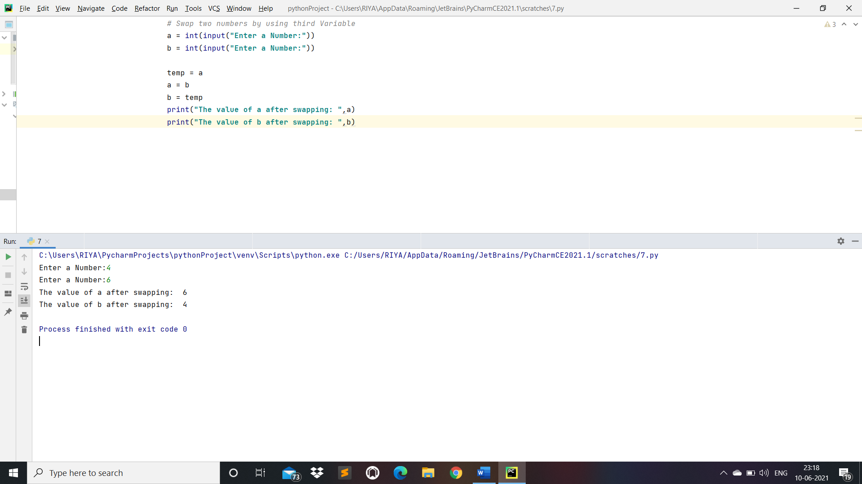

Practical 8:- Take two numbers and find smallest number.

Code:

a = int(input(**"Enter a Number : "**))  
b = int(input(**"Enter a Number : "**))  
  
**if** a < b:  
 print(**"a is smaller number"**)  
  
**elif** b < a:  
 print(**"b is smaller number"**)  
**else**:  
 print(**"Both the numbers are equal"**)

O/P:

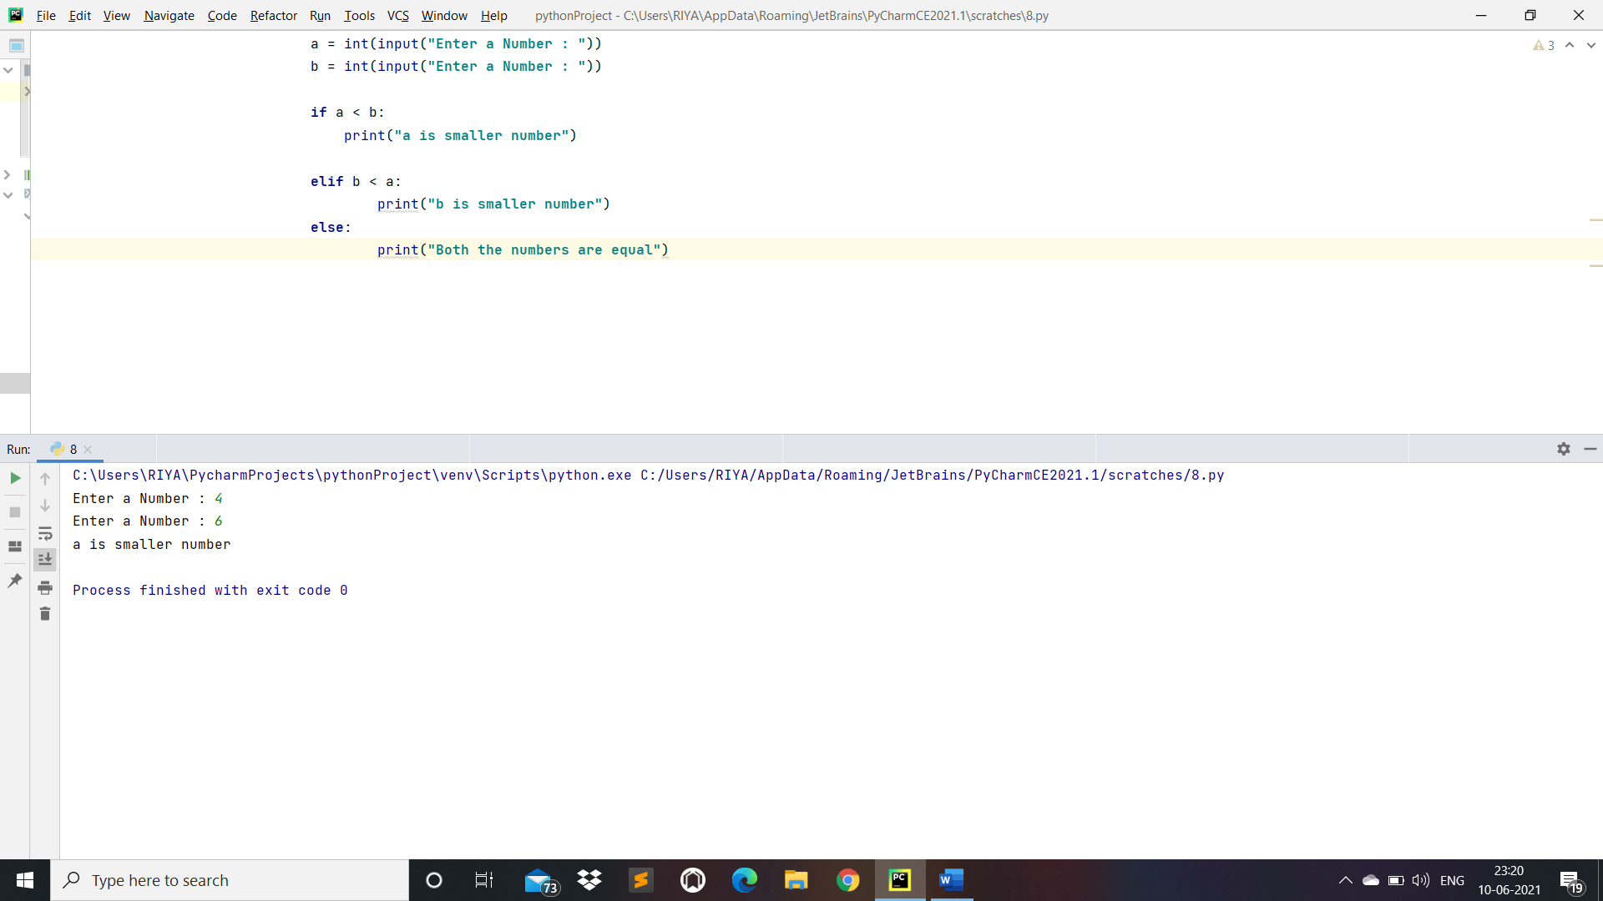

Practical 9:- Take a number check if a number is less than 100 or not. If it is less than 100 then check if it is odd or even.

Code:

x = int(input(**"Enter a Number:"**))  
**if** x < 100:  
 print(**"The number is less than 100"**)  
 **if** x % 2 == 0:  
 print(**"x is even"**)  
 **else**:  
 print(**"x is odd"**)  
**else**:  
 print(**"The number is greater than 100"**)

O/P:

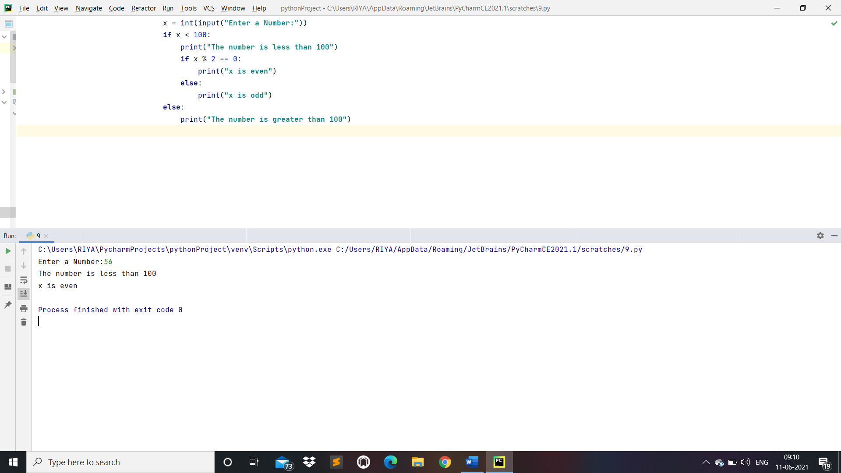

Practical 10:- Take a number to print the square of a number if it is less than 10.

Code:

x = int(input(**"Enter a number:"**))  
  
**if** x < 10:  
 print(**"Square of an number:"**, x * x)  
**else**:  
 print(**"The number is greater than 10"**)

O/P:

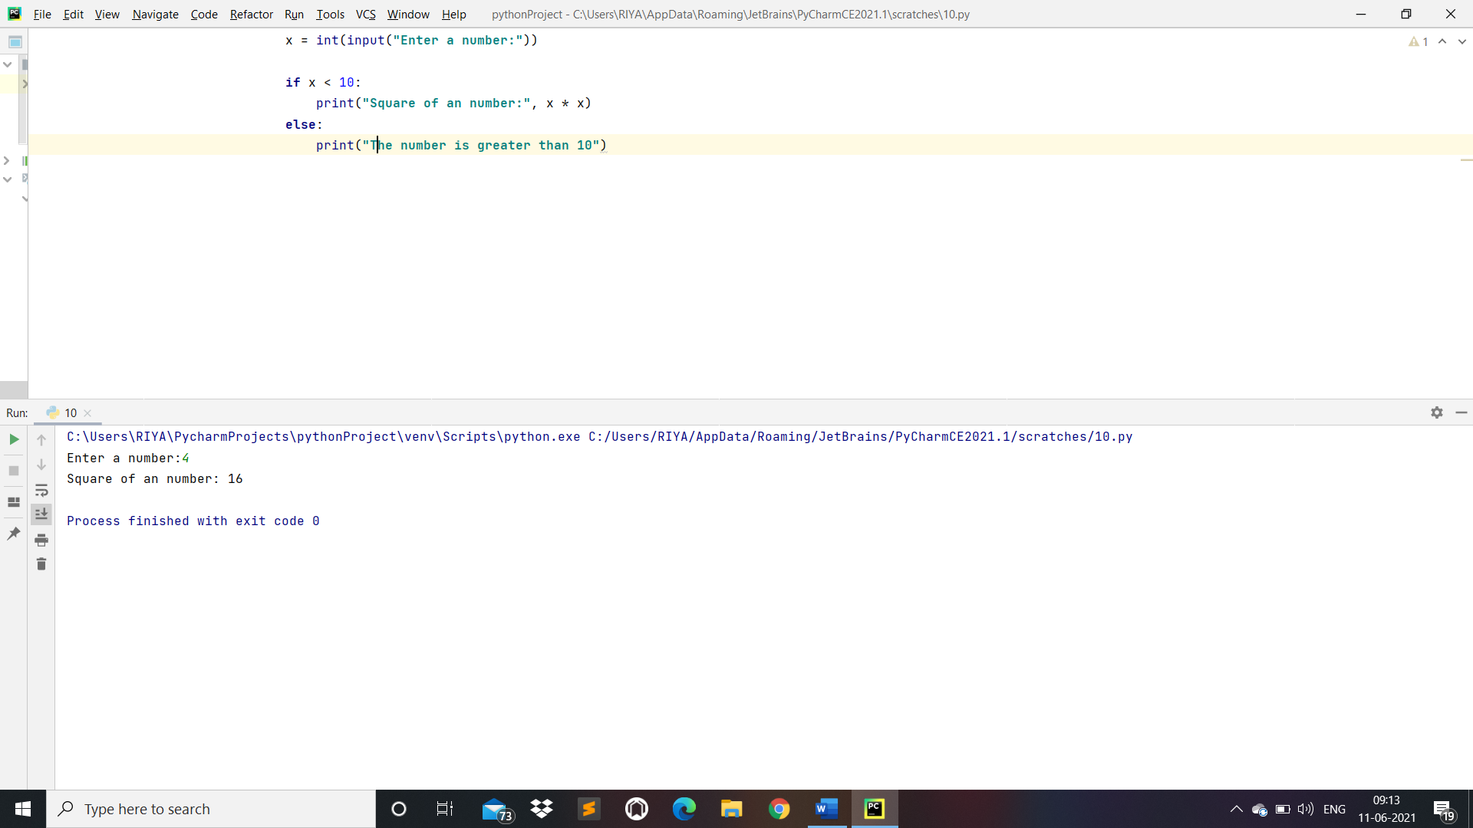

Practical 11:- Take a number and check whether it is zero, positive or negative using Nested IF…ELSE statement.

Code:

x = int(input(**"Enter a Number:"**))  
  
**if** x >= 0:  
 **if** x == 0:  
 print(**"x is Zero"**)  
 **else**:  
 print(**"x is a positive number"**)  
**else**:  
 print(**"x is a negative number"**)

O/P:

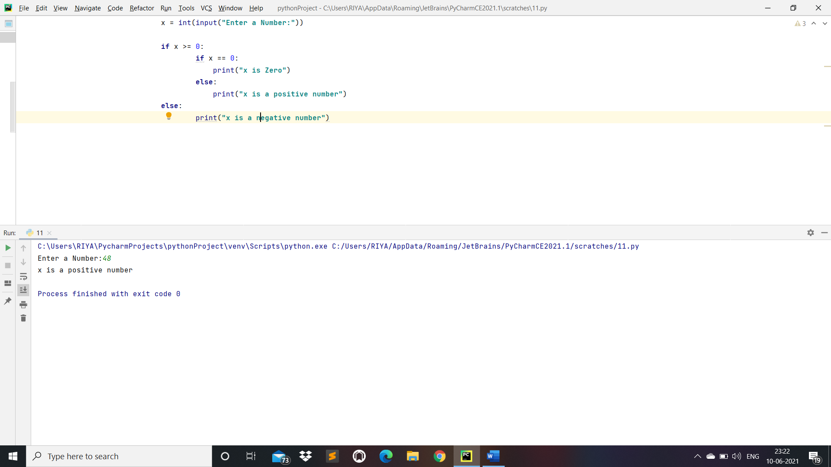

Practical 12:- Take 3 numbers and find greatest number using IF….ELSE statement.

Code:

x = int(input(**"Enter a Number:"**))  
y = int(input(**"Enter a Number:"**))  
z = int(input(**"Enter a Number:"**))  
  
**if** x > y:  
 **if** x > z:  
 print(**"x is larger number"**)  
 **else**:  
 print(**"z is larger number"**)  
**else**:  
 print(**"y is larger number"**)

O/P:

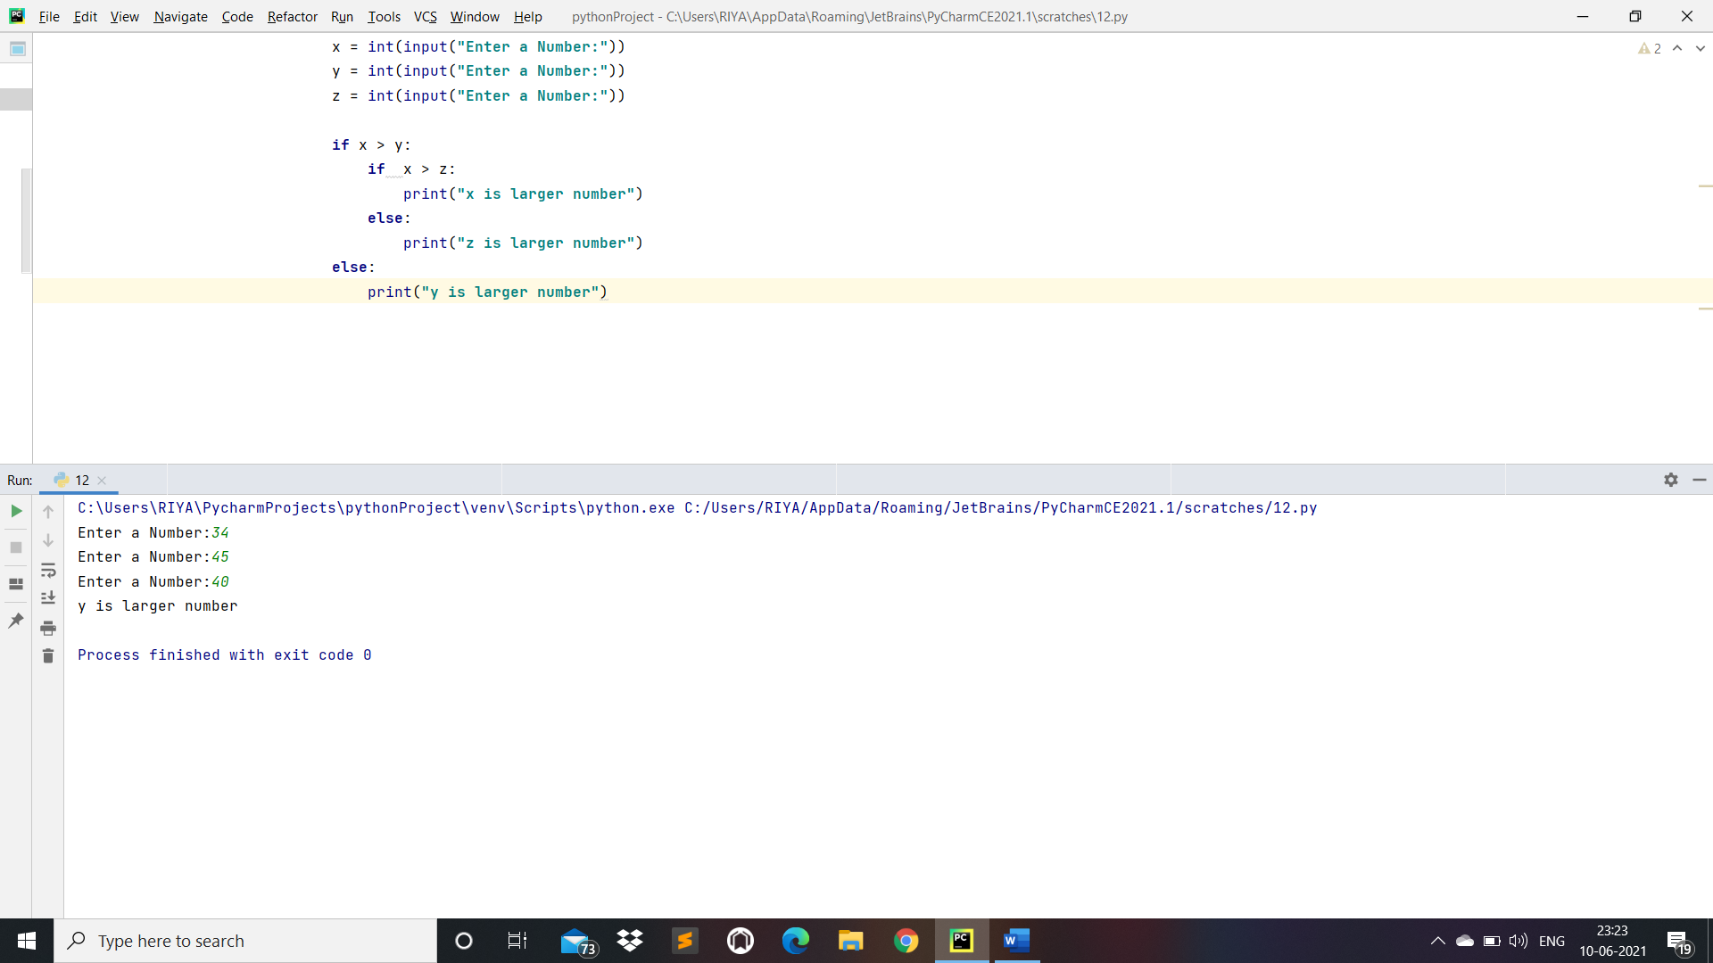

Practical 13:- Take 3 numbers and find smallest number using logical operator.

Code:

x = int(input(**"Enter a Number:"**))  
y = int(input(**"Enter a Number:"**))  
z = int(input(**"Enter a Number:"**))  
  
**if** x < y **and** x < z:  
 print(**"x is smallest number"**)  
   
**elif** y < x **and** y < z:  
 print(**"y is smallest number"**)  
  
**elif** z < y **and** z < x:  
 print(**"z is smallest number"**)  
  
**else**:  
 print(**"either two or three values are equal"**)

O/P:

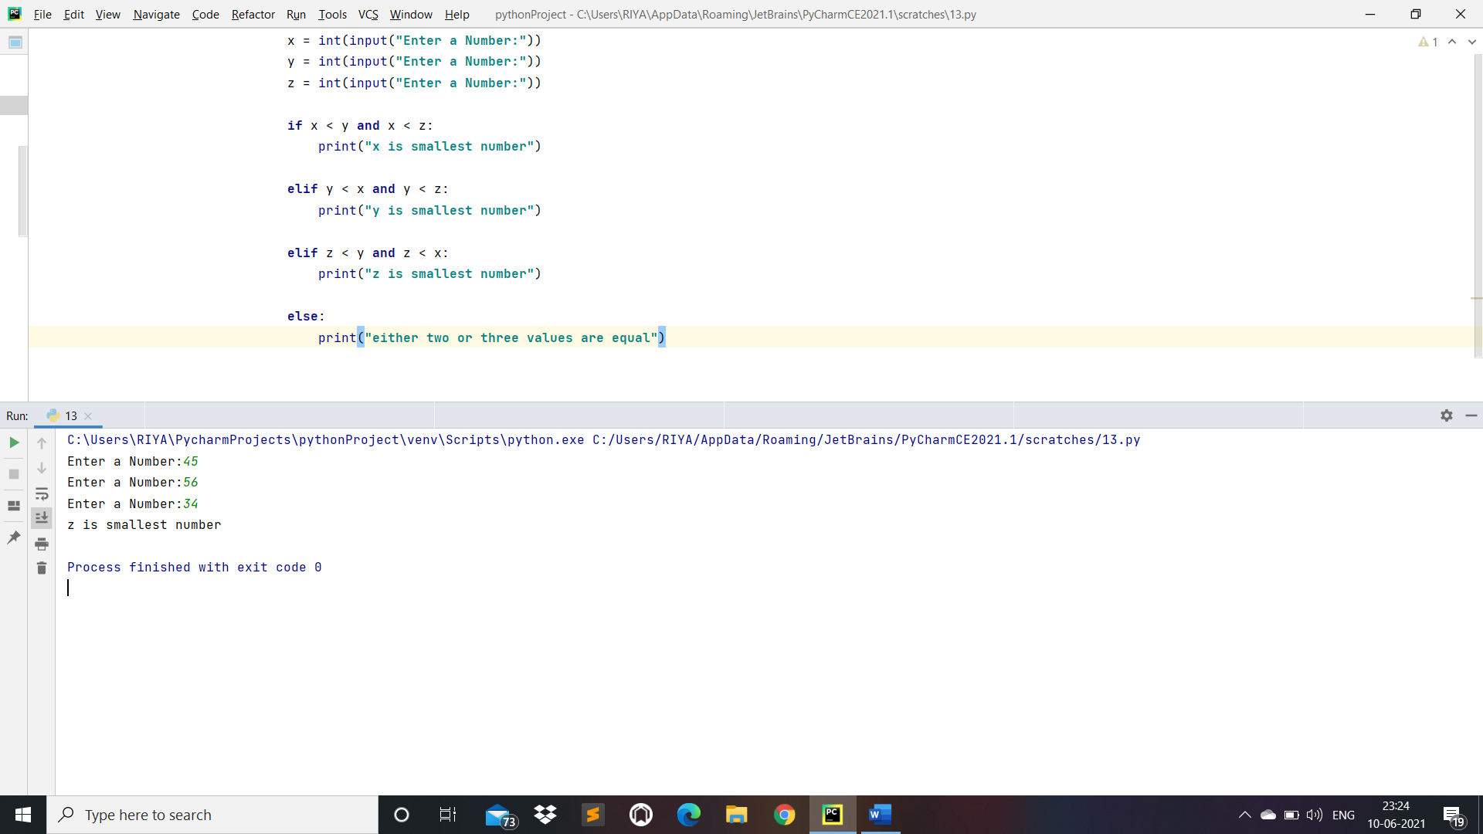

Practical 14:- Write a Program to swap two numbers without taking third variable.

Code:

a = int(input(**"enter a number:"**))  
b = int(input(**"enter a number:"**))  
  
a, b = b ,a  
print(**"Value of a after swapping"**, a)  
print(**"Value of b after swapping"**, b)

O/P:

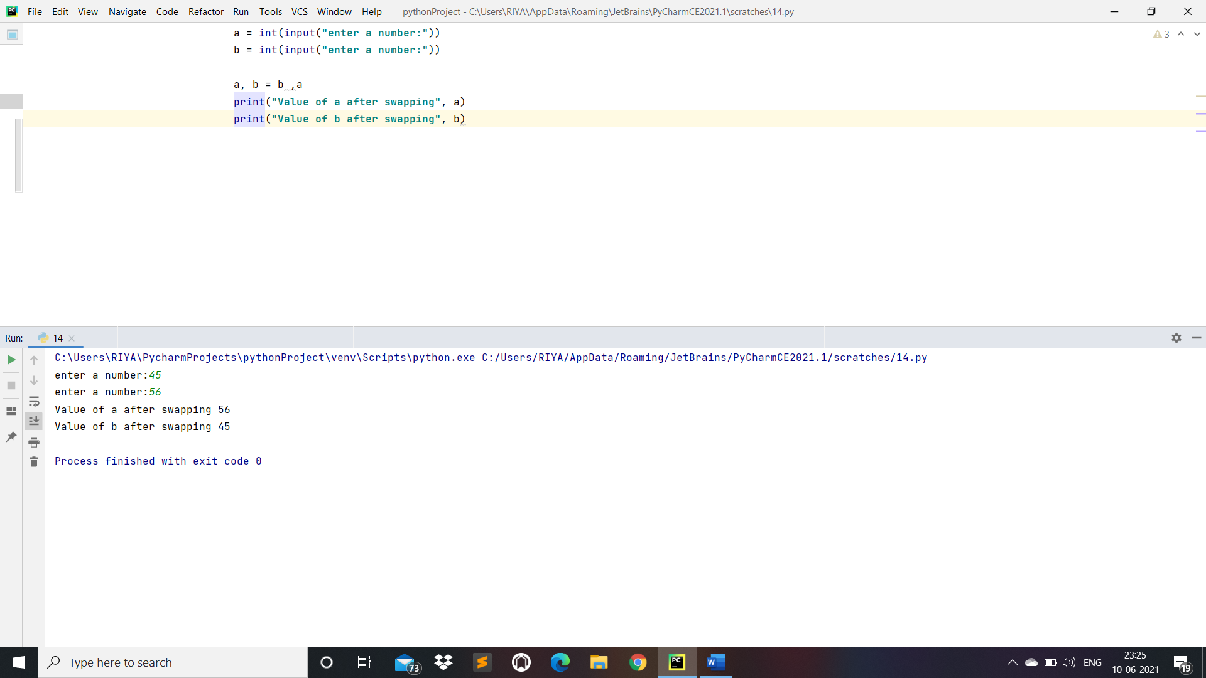

Practical 15:- Take Starting number and ending number from the use and print a following series.

O/P: Enter starting number: 30

Enter ending number: 0

30

27

24

21

18

Code:

a = int(input(**"Enter a starting number:"**))  
b = int(input(**"Enter an ending number:"**))  
  
**for** i **in** range(30, 0, -3):  
 print(i, end = **""**)  
 print()

O/P:

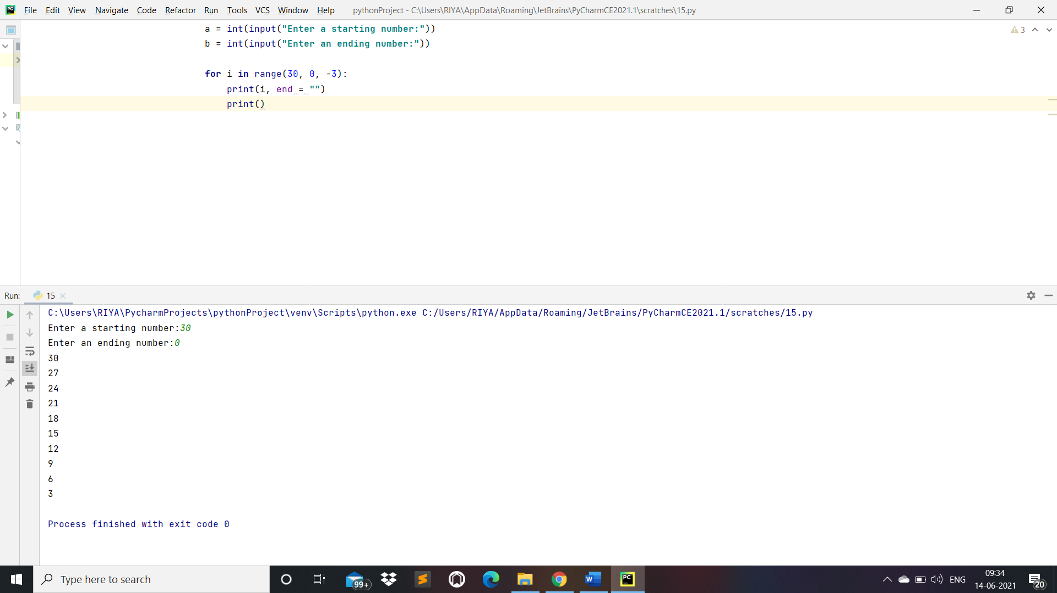

Practical 16: Make a Website using registration form and signup and display it on second page.

base.html:

{% load static %}

<html xmlns="http://www.w3.org/1999/xhtml">

<head>

<meta name="keywords" content="" />

<meta name="description" content="" />

<meta http-equiv="content-type" content="text/html; charset=utf-8" />

<title>Stampalike by FCT</title>

<link href="http://fonts.googleapis.com/css?family=Arvo" rel="stylesheet" type="text/css" />

<link href="http://fonts.googleapis.com/css?family=Coda:400,800" rel="stylesheet" type="text/css" />

<link href="{% static 'style.css' %}" rel="stylesheet" type="text/css" media="screen" />

</head>

<body>

<div id="menu-wrapper">

    <div id="menu">

        <ul>

            <li class="current_page_item">

            <a href="/">Home</a></li> |

            <li><a href="/about">About</a></li> |

            <li><a href="/contact">Contact</a></li> |

            <li><a href="/signin">Sign in</a></li> |

            <li><a href="/register">Register</a></li>

        </ul>

    </div>

    <!-- end #menu -->

</div>

<div id="header-wrapper">

    <div id="header">

        <div id="logo">

            <h1><a href="/">stampAlike</a></h1>

            <p>Template by <a href="http://www.freecsstemplates.org">FCT</a></p>

        </div>

    </div>

</div>

<div id="wrapper">

    <!-- end #header -->

    <div id="page-bgtop"></div>

    <div id="page">

        <div><img src="{% static 'images/pics01.jpg' %}" width="920" height="300" alt="" /></div>

        {% block content %}

        {% endblock %}

        <!-- end #sidebar -->

        <div style="clear: both;">&nbsp;</div>

    </div>

    <div id="page-bgbtm"></div>

    <!-- end #page -->

</div>

<div id="footer">

    <p>2012. Sitename.com. All rights reserved. Design by <a href="http://www.freecsstemplates.org/">FCT</a>. Photos by <a href="http://fotogrph.com/">fotogrph</a>.</p>

</div>

<!-- end #footer -->

</body>

</html>

O/P:



home.html:

{% extends 'base.html' %}

{% block content %}

<h1><center><b>Welcome ,</b></center></h1>

{% endblock %}

about.html

{% extends 'base.html' %}

{% block content %}

<h1><center>Welcome to My About Us Page</center></h1>

{% endblock %}

O/P:



contact.html:

{% extends 'base.html' %}

{% block content %}

<h1><center>Welcome to My Contact Us Page</center></h1>

{% endblock %}

O/P:



Signin.html:

{% extends 'base.html' %}

{% block content %}

<html>

<body>

<h1><center>Sign in</center></h1>

<form method = "post" action = "/signinprocess" target = "/blank">

{% csrf_token %}

Email Address: <input type = "mail" name = "email">

<br/><br/>

Password: <input type = "password" name = "pwd">

<br/><br/>

<input type = "submit">

</form>

</body>

</html>

{% endblock %}

O/P:





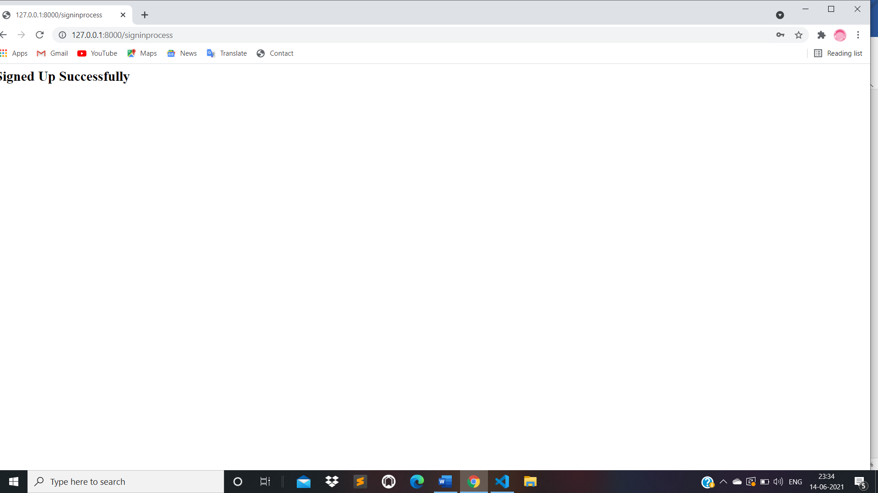

register.html:

<html>

<body bgcolor = "skyblue">

    <form method = "post" action = "/formprocess" target = "_blank">

    {% csrf_token %}

    <h1><center>Registration Form<center></h1><br/>

    Full Name: <input type = "text" name = "txt" required><br/><br/>

    Email: <input type = "email" name = "email" required><br/><br/>

    Gender:<br/>

            <input type = "radio" id = "male" name = "gender">Male<br/>

            <input type = "radio" id = "female" name = "gender">Female<br/>

            <input type = "radio" id = "other" name = "gender">Other<br/><br/>

    Mobile No.: <input type = "tel" name = "phone" pattern = "[0-9]{10}" placeholder = "1234567890"><br/></br/>

    Address: <textarea rows = "8" cols = "20" name = "home">

    </textarea><br/>

    Date-Of-Birth: <input type = "date" name = "birthday"><br/>

    Upload CV:<br/>

    <input type = "file" name = "myfile"><br/><br/>

    <input type = "submit" value = "Submit">

    <input type = "reset" value = "Reset">

    </form>

</body>

</html>

O/P:

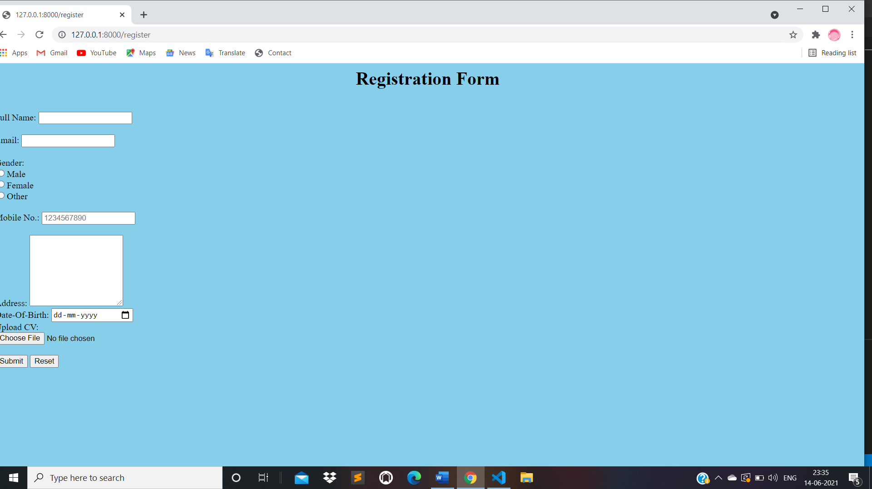

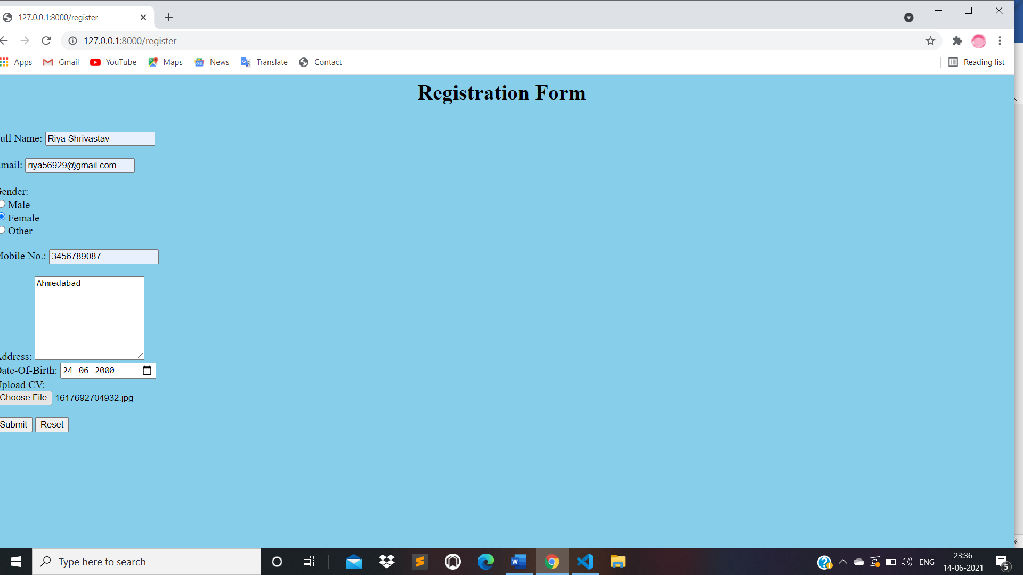

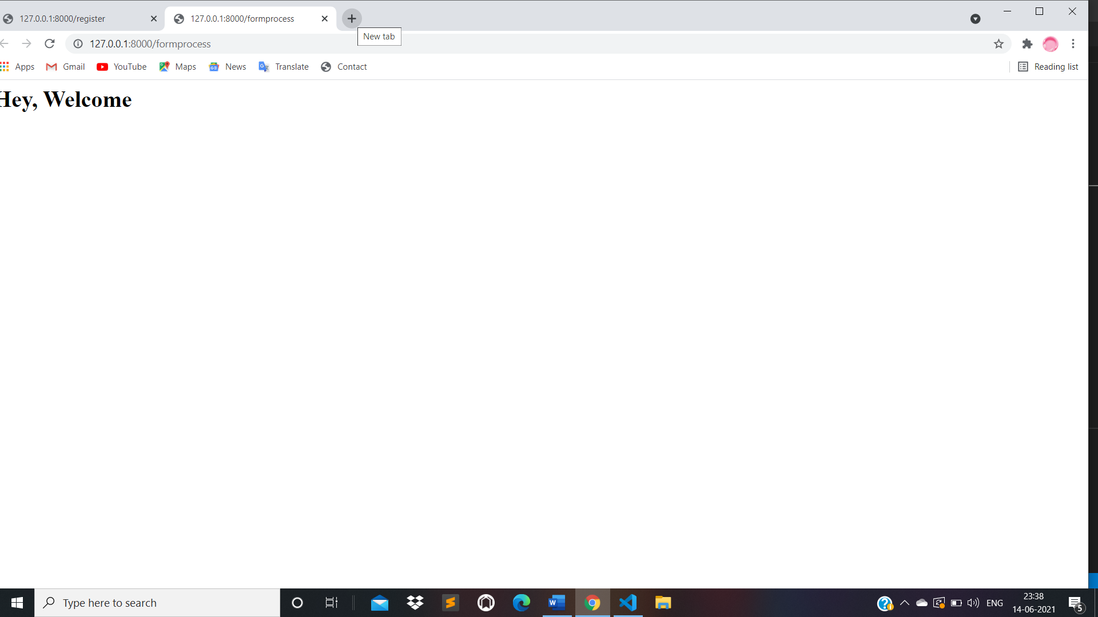

views.py:

from django.shortcuts import render

from django.http import HttpResponse

def homepageview(request):

    return render(request, 'home.html')

def aboutpageview(request):

    return render(request, 'about.html')

def contactpageview(request):

    return render(request, 'contact.html')

def signinpageview(request):

    return render(request, 'signin.html')

def registerpageview(request):

    return render(request, 'register.html')

def process(request):

    return render(request, 'welcome.html')

def signinprocess(request):

    return render(request, 'signed.html')

urls.py:

from django.urls import path

from . import views

urlpatterns = [

    path('', views.homepageview, name = 'home'),

    path('about', views.aboutpageview, name = 'about'),

    path('contact', views.contactpageview, name = 'contact'),

    path('signin', views.signinpageview, name = 'signin'),

    path('register', views.registerpageview, name = 'register'),

    path('formprocess', views.process, name = 'process'),

    path('signinprocess', views.signinprocess, name ='signinprocess'),

]